Technical Bid
- General Information of the Bidder:
 | Name of the company/Organization
 | Address of Office
 | Office Contact Number
 | E Mail
 | Website
 | Name and designation of the representative of the tenderer to whom all references shall be made | - Name
 |  | - Designation
 |  | - Email
 |  | - Mobile No.
 | Refundable Earnest Money Deposited |  | Submit Deposit Slip
 | Nature of the Company |  | Proprietary/Partnership/ Private Ltd/ Public Ltd
 | Proprietor/Partner/Chief Executive Name and Contact No. | - Name
 | Proprietor/Partner/Chief Executive Name and Contact No. | - Mobile No.
 | Nature of Business |  | Distributor/Dealer/Trader/Manufacturer
 | Year of starting business
 | Scope (Category) of Supply
 | Registration Certificate |  | Submit copy
 | Renewal Certificate |  | Submit copy
FINANCIAL & COMMERCE
 | Bank Detail of Tenderer | - Account Name
 | Bank Detail of Tenderer | - Account No.
 | Bank Detail of Tenderer | - Account Type
 | Bank Detail of Tenderer | - Bank Name
 | Bank Detail of Tenderer | - Bank Branch
 | Value of total sales during the previous Year
 | Tax Clearance certificate |  | Submit copy
 | Cliental List |  | Enclose details indicating name with address of customer, product supplied and year of supply
 | PAN/VAT Registration Certificate |  | Submit copy
 | Pictures of the items quoted for along with the detail specification |  | Submit Pictures and Detail Specification of the items (Bidders must submit the pictures of all the items they have quoted for along with the detail specification and user manual if any)
 | After Sales Service |  | Submit detail of after sales service of each item (Refer to Section C for Detail)
 | Any additional information you would like to provide??
Note: Please fill in the vendor registration form for FY 2083/84 if you or your firm is not registered in LI-BIRD’s vendor roster. Refer to the following link for the Vendor Registration Form: LI-BIRD - Vendor Registration Form 83/84

- Technical Specification
B.1. Scope of Work
The scope of work of the vendor is the supply and delivery of high-quality crop processing machineries to support beneficiaries of RERAS project in Bajura, Jumla and Sindhuli sites. The vendor will be fully responsible for ensuring that all supplied items strictly confirm to the approved technical specifications and quality standards with timely delivery of the items to designated delivery points. The items with the delivery points are as follows:
S.N. | Items | Unit | Total Quantity | Delivery Point | Remarks
1 | Electric Multi-Crop Thresher | Pcs | 50 | - 13 pcs in Chandannath MC, Jumla  - 18 pcs in Budhiganga MC-Phalasain, Bajura  - 19 pcs in Jaganaath RMC-Pilichaur, Bajura
2 | Electric Rice Mill-Mini | Pcs | 18 | - 3 pcs in Chandannath MC, Jumla  - 15 pcs in Jaganaath RMC-Pilichaur, Bajura
3 | Electric Grain Grinder | Pcs | 18 | - 4 pcs in Chandannath MC, Jumla  - 1 pcs in Budhiganga MC-Phalasain, Bajura  - 13 pcs in Jaganaath RMC-Pilichaur, Bajura
4 | Electric Corn Sheller | Pcs | 36 | - 10 pcs in Sunkoshi RMC, Sindhuli  - 8 pcs in Chandannath MC, Jumla  - 18 pcs in Budhiganga MC-Phalasain, Bajura
5 | Compact Rice Husker & Polisher | Pcs | 4 | - 2 pcs in Chandannath MC, Jumla  - 1 pcs in Budhiganga MC, Phalasain Bajura  - 1 pcs in Jagannath RMC, Pilichaur Bajura
6 | Disc Floor Mill (Masala) | Pcs | 1 | - 1 pcs in Budhiganga MC, Phalasain Bajura
7 | Oil Expeller Mill | Pcs | 1 | - 1 pcs in Jaganaath RMC-Pilichaur, Bajura
Note: The detailed specification of different items should comply with Section B.2. Compliance with Specification

B.2. Compliance with Specifications
The technical specifications are a minimum checklist for evaluating compliance; referenced brands or models or pictures are indicative only, and equivalent equipment is acceptable. For each item, bidders shall write “Yes, in compliance with specification” and cite relevant reference documents in the next column; if there is any deviation, it must be clearly stated in the compliance column.
S.N. | Items | Specifications | Compliance with Specification | Reference Document (Specify Document) | Reference Picture
1 | Electric multi-crop thresher | - Power: 2.5-3 HP (Single phase motor)  - Threshing Capacity: 500-600 kg per hour  - Weight: 50-65 Kg  - Overall size: 1500*1020*1170 mm  - Roller Speed: 700 rpm  - Roller Diameter: 230 mm  - Roller length: 750 mm  - Transportation Wheel: Tyre  - Body Material: Iron  - Mode of operation: Electric- Single Phase  - Use: Threshing finger millet, wheat and paddy |  |  | 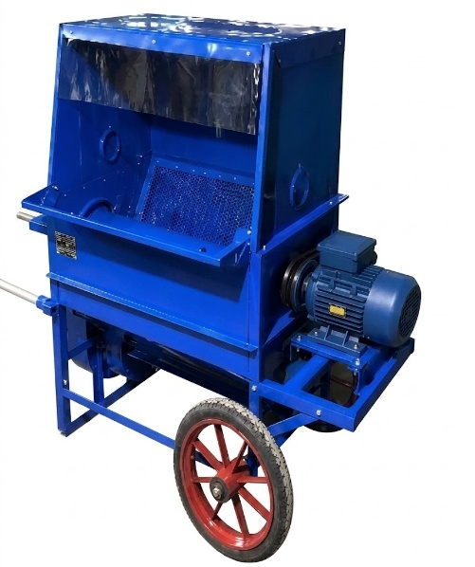
2 | Electric rice mill-Mini | - Power: 2.5-3 HP (Single phase motor)  - Weight: 46 Kg  - Capacity: 120-150 Kg/hr  - Size: 640*400*1165 mm  - Body Material: Iron  - Mill Type: Disc Type  - Mode of Operation: Electric- Single Phase  - Use: Milling rice |  |  | 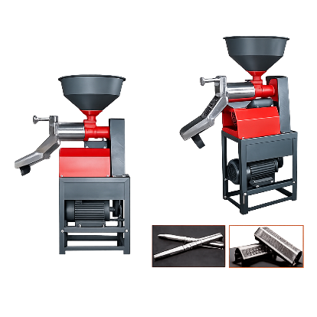
3. | Electric grain grinder | - Power: 5-6 HP motor (Single phase motor)  - Motor weight: 55-65 Kg  - Grinder Diameter: 18 inch  - Body weight: 75-85 Kg  - Body Material: Iron  - Capacity: 50 Kg/Hr  - Mode of operation: Electric- Single Phase  - Use: Grinding grain and spices |  |  | 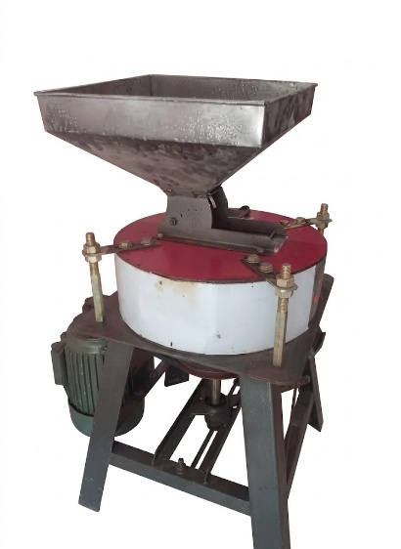
4 | Electric Corn Sheller | - Power: 1.1-1.5HP (Single phase motor)  - Capacity: 1500 kg per hour  - Motor weight: 28-32 Kg  - Body Dimension: 1050*440*700 mm  - Body Material: Iron  - Material of Motor: Aluminum, copper  - Mode of operation: Electric- Single Phase  - Use: Threshing maize |  |  | 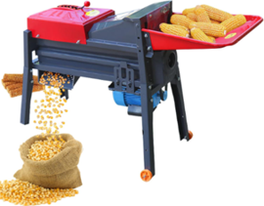
5 | Compact Rice Husker & Polisher | - Power: 220 V/2.2 KW HP (single phase motor)  - Weight: 150 Kg  - Capacity: 150Kg/hr  - Body Material: Iron  - Mode of operation: Electric- Single Phase  - Use: Milling rice and polishing grains |  |  | 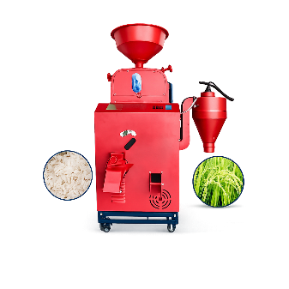
6 | Disc Floor Mill (Masala) | - Power: 3 HP (Single phase motor)  - Voltage: 220 V  - Weight: 30 Kg  - Capacity: 100Kg/hr  - Body Material: Iron  - Mode of operation: Electric-Single Phase  - Use: Masala Making |  |  | 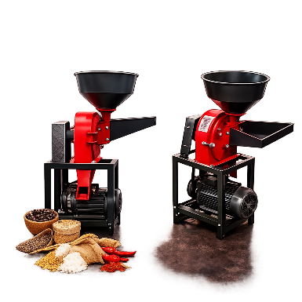
7 | Oil Expeller Mill | - Power required: 7.5-10 HP (Motor not required)  - Voltage: 440 V  - Weight: 250 Kg  - Capacity: 45-50 Kg/hr  - Body Material: Iron  - Mode of operation: Electric (Three phase)  - Use: For all Seed oils |  |  | 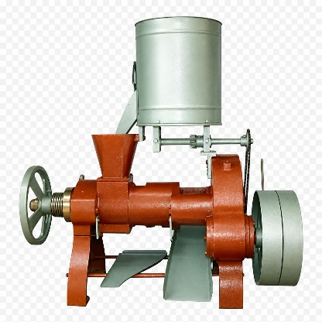

- AFTER-SALES SERVICE, WARRANTY AND TECHNICAL SUPPORT
The bidder shall provide comprehensive after-sales services for all agricultural machinery and equipment supplied under this procurement. The following requirements shall be mandatory:
- Warranty: The supplier shall provide a minimum 12-month warranty from the date of successful installation, testing, commissioning, and handover of the equipment. The warranty shall cover manufacturing defects and damage during transportation of delivery.
- Installation and Commissioning: The supplier shall be responsible for transportation, installation, testing, commissioning, and demonstration of all machinery/equipment at the designated location(s), where applicable.
- User Training: The supplier shall provide operation and troubleshooting orientation at each delivery point
- Repair and Maintenance: During the warranty period, the supplier shall provide necessary technical support and repair/maintenance services. Any defective parts covered under warranty shall be repaired or replaced by the supplier at no additional cost to the project/beneficiary.
- Replacement of Defective Equipment: If any machinery/equipment is found to have a major manufacturing defect or repeatedly fails during the warranty period despite repair, the supplier shall be required to replace the defective unit or major component, as determined by the purchaser.
- Response Time: In case of a breakdown or technical complaint during the warranty period, the supplier shall respond within 48 hours of receiving the complaint and initiate necessary corrective action within a reasonable period. For critical breakdowns, the supplier shall prioritize the repair/service.
- Service Documentation: The supplier shall provide operation and maintenance manuals, warranty certificates, service contact details, and recommended maintenance schedules along with the equipment.
- Service Cost: All costs related to warranty repairs/replacement, including labour, service charges, and defective parts, shall be borne by the supplier during the warranty period, except where the damage is caused by misuse, negligence, or unauthorized modification by the user.

- Procedure for Submission of Tender
- Bidders must submit the following documents:
  - Technical Bid: It shall contain the information about the bidder i.e. experience and past performance in the execution of similar bids, capacity etc. and documents required for the bidding process.
  - Financial Bid: It shall contain the price quotation.
  - Deposit Slip: The bidders must deposit a sum equal to two and half percent of bid amount as Earnest Money at LI-BIRD’s bank account. Bidders must submit the deposit slip with the Financial Bid. The bank details are:
  - Account Name: LI-BIRD
  - Account Number: 1201017500829
  - Bank Name: Nabil Bank Ltd
  - Branch: Sabhagricha Chowk, Pokhara
Note: The deposited amount will be returned to the unsuccessful bidders within 7 days of the result announcement.
- Bidders must sign in each page of the Technical Bid Form in acceptance of terms and conditions laid down in the tender document, failing which it will be presumed that the bidder is not willing to accept the terms and conditions of the tender and will be liable for rejection.
- Both bidding forms should be enclosed in one big sealed envelope super-scribing “Tender for Supply of Agri Machinery Items 2026”.
- Bidders should invariably mention their name, address etc. on the left-hand side of the envelope for clear identification.

- EVALUATION CRITERIA
I | Documentary Technical Evaluation (60 Marks)
1. | Organizational Experience and Capacity (20)
1.1 | Years of Operation and General Experience in Agricultural Machinery Supply (5)
1.2 | Specific Experience with Evidence of Successfully Completing at least 3 Similar Assignment in the last 3 years (10)
1.3 | Positive Feedback from Previous Clients specifically NGOs, INGOs, Government Agencies or Commercial Farms (5)
2. | Technical Compliance and Product Quality (25)
2.1 | Compliance with technical specification and supporting documentation (15)
2.2 | Product Quality, Durability and Operational Performance (10)
3. | After-Sales Service, Warranty and Technical Support (15)
3.1 | Warranty Coverage (3)
3.2 | Spare Parts Availability Commitment (3)
3.3 | Technical Service Capacity (3)
3.4 | Response Time and Maintenance Support Commitment (3)
3.5 | Installation, Commissioning, User Training and Documentation (3)
II | Physical Verification Evaluation (40 Marks)
1 | Physical Verification of Product Quality, Materials, Construction, and Compliance with Specifications (20)
1.1 | Verification of Product Quality and Compliance (15)
1.2 | Demonstration and Operational Performance (5)
2 | Capacity, Logistics and Service Infrastructure Verification (20)
2.1 | Warehouse, Inventory and Quality Control System (8)
2.2 | Delivery and Logistics Capacity (6)
2.3 | After-Sales Service Infrastructure (6)
The vendor will be selected based on the Quality and Cost Based Scoring (70:30)

Note: Submission Requirements and Shortlisting for Physical Verification
Bidders must submit adequate documentary evidence demonstrating their general experience, past performance, organizational capacity, and compliance with the required technical specifications. Failure to provide sufficient evidence supporting any of the mandatory evaluation criteria may result in the bidder receiving a low score or being deemed non-responsive during the Documentary Technical Evaluation stage. The evaluation process shall be conducted in two stages:
- Documentary Technical Evaluation (60 points)
- Physical Verification Evaluation (40 points)
Only bidders who achieve a minimum score of 40 out of 60 points in the Documentary Technical Evaluation shall be shortlisted and invited to proceed to the Physical Verification stage. Bidders scoring below 40 points in the Documentary Technical Evaluation shall be considered technically non-responsive and shall not be eligible for physical verification. The Physical Verification Evaluation will assess the bidder's actual capacity, including but not limited to product quality, stock availability, warehouse and storage facilities, quality control systems, and logistics arrangements.

The Total Technical Score shall be calculated by combining the Documentary Technical Evaluation score (60 points) and the Physical Verification Evaluation score (40 points), resulting in a maximum technical score of 100 points.

LI-BIRD reserves the right to conduct physical verification of the bidder's office, warehouse, inventory, equipment, product samples, and logistical capacity. Any significant discrepancy identified between the submitted documents and the findings of the physical verification may result in score reduction or disqualification.

- RECEIPT OF TENDERS
- The sealed tender should reach the office of LI-BIRD through Courier Service/By Hand only on or before 18 September 2026 up to 5:00 PM. Only hard copies of sealed bids shall be considered. No e-documents will be considered in the bidding process.
- The interested bidders can submit the sealed tender either at Programme Coordination Office of LI-BIRD at Sanepa, Lalitpur or at Head Office of LI-BIRD at Pokhara–11, Kaski.
- Tenders received after the schedule date and time shall not be entertained.

- TERMS AND CONDITION FOR SUPPLY OF AGRI MACHINERY ITEMS
- Bidders are requested to quote the price on a per unit basis for items mentioned in section B of this document.
- The rate quoted should be net including all costs (taxes) and delivery at the delivery points mentioned in section B of this document.
- LI-BIRD reserves the right to segregate the quantity of items between two or more bidders.
- LI-BIRD reserves the right to not proceed with this procurement at any stage or to accept or reject any or all applications without any explanation whatsoever.
- The successful bidder will be responsible for supply of Agri Machinery Items mentioned in the Bidding Form and quantities thereof as agreed.
- The successful bidder shall not change the committed quantities without the consent of LI-BIRD.

- PENALTY
- In case the successful bidder fails to supply the agreed quantities of Agri Machinery Items within the time period specified. LI-BIRD shall not be liable to pay the committed amount to the successful bidders.
- In case of any complaint received from the user or defect found on the Agri Machinery Items, the successful bidder would be liable to pay compensation as per the claims/decision reached through negotiation.
- Above penalty clauses shall not be applicable in case that natural calamity is the sole cause for the failure then LI-BIRD may waive the penalty, but it shall be sole discretion of LI-BIRD.

- SUBMISSION OF DOCUMENT AFTER SUPPLY OF AGRI MACHINERY ITEMS AND PAYMENT THEREOF
- The challan no. and date should invariably be indicated in the Invoice, when raised by the selected bidder.
- The successful bidder must in any case provide authorized bills after the successful delivery of the items.

- AGREEMENT AND OTHER TERMS AND CONDITIONS
- The bids will be opened on 21 September 2026 at 3:00 pm at LI-BIRD Head Office, Pokhara.
- The successful bidder will execute an agreement with LI-BIRD for arranging the supply of required value as per terms and conditions.
- If there arises any dispute between the parties, both will agree to accept the decision reached through mutual understanding.
- LI-BIRD has full right to accept or reject all or any bidder without assigning any reason thereof.

