Technical Bid
- General Information of the Bidder:
 | Name of the company/Organization
 | Address of Office
 | Office Contact Number
 | E Mail
 | Website
 | Name and designation of the representative of the tenderer to whom all references shall be made | - Name
 |  | - Designation
 |  | - Email
 |  | - Mobile No.
 | Refundable Earnest Money Deposited |  | Submit Deposit Slip
 | Nature of the Company |  | Proprietary/Partnership/ Private Ltd/ Public Ltd
 | Proprietor/Partner/Chief Executive Name and Contact No. | - Name
 | Proprietor/Partner/Chief Executive Name and Contact No. | - Mobile No.
 | Nature of Business |  | Distributor/Dealer/Trader/Manufacturer
 | Year of starting business
 | Scope (Category) of Supply
 | Registration Certificate |  | Submit copy
 | Renewal Certificate |  | Submit copy
FINANCIAL & COMMERCE
 | Bank Detail of Tenderer | - Account Name
 | Bank Detail of Tenderer | - Account No.
 | Bank Detail of Tenderer | - Account Type
 | Bank Detail of Tenderer | - Bank Name
 | Bank Detail of Tenderer | - Bank Branch
 | Value of total sales during the previous Year
 | Tax Clearance certificate |  | Submit copy
 | Cliental List |  | Enclose details indicating name with address of customer, product supplied and year of supply
 | PAN/VAT Registration Certificate |  | Submit copy
 | Pictures of the items quoted for along with the detail specification |  | Submit Pictures and Detail Specification of the items (Bidders must submit the pictures of all the items they have quoted for along with the detail specification and user manual if any)
 | After Sales Service |  | Submit detail of after sales service of each item
 | Any additional information you would like to provide??
Note: Please fill in the vendor registration form for FY 2082/83 if you or your firm is not registered in LI-BIRD’s vendor roster. Refer to the following link for the Vendor Registration Form.
- https://hrp.libird.org/li-bird-vendor-registration?new=1

- Technical Specification
B.1. Scope of Work
The scope of work of the vendor is the supply and delivery of high-quality agriculture inputs to support beneficiaries of EMPOWER project in Kolti, Bajura sites. The vendor will be fully responsible for ensuring that all supplied items strictly conform to the approved technical specifications and quality standards with timely delivery of the items to designated delivery points. The items with the delivery points are as follows:
S.N. | Items | Unit | Total Quantity | Delivery Points | Remarks
1 | Watering cane | Pcs | 991 | Budinanda MC, Kolti, Bajura
2 | Yellow sticky trap | Pcs | 2973 | Budinanda MC, Kolti, Bajura
3 | Neem biopesticide | Bottle (50 ml) | 991 | Budinanda MC, Kolti, Bajura
4 | Seedling tray | Pcs | 1325 | Budinanda MC, Kolti, Bajura
5 | Jholmol Drum | Pcs | 334 | Budinanda MC, Kolti, Bajura
6 | Effective Mico-organism (EM) | Bottle | 334 | Budinanda MC, Kolti, Bajura
7 | Hand Sprayer | Pcs | 334 | Budinanda MC, Kolti, Bajura
8 | Sprinkler | Pcs | 991 | Budinanda MC, Kolti, Bajura
9 | Poultry Drinker | Pcs | 86 | Budinanda MC, Kolti, Bajura
10 | Poultry Feeder | Pcs | 86 | Budinanda MC, Kolti, Bajura
11 | Poultry Chick Feed | Kg | 430 | Budinanda MC, Kolti, Bajura | 86 packs (each pack contains 5 kg)
Note: The detailed specification of different items should comply with Section B.2. Compliance with Specification

B.2. Compliance with Specifications
The technical specifications are a minimum checklist for evaluating compliance; referenced brands or models or pictures are indicative only, and equivalent equipment is acceptable. For each item, bidders shall write “Yes, in compliance with specification” and cite relevant reference documents in the next column; if there is any deviation, it must be clearly stated in the compliance column.

S.N. | Items | Specifications | Compliance with Specification | Reference Document (Specify Document) | Reference Picture
1 | Watering cane | - Capacity: 10 liters.  - Material: High-density polyethylene (HDPE) or durable plastic.  - UV-resistant and rust-free.  - Fitted with removable sprinkler rose/nozzle.  - Ergonomic handle for easy carrying.  - Leak-proof construction suitable for agricultural use. |  |  | 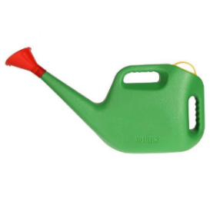
2 | Yellow sticky trap | - Size: A4 (210 × 297 mm).  - Material: UV-stabilized plastic/polymer or paper board with Pressure Sensitive Adhesive (PSA) and release paper.  - Color: Bright yellow.  - Sticky on both sides.  - Life span: Approximately 1 month under field conditions.  - Suitable for monitoring and controlling aphids, whiteflies, leaf miners, thrips, and other small flying insects. |  |  | 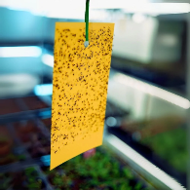
3. | Neem biopesticide | - Azadirachtin content: Minimum 300 PPM.  - Packaging: 50 ml sealed bottle.  - Formulation: Liquid botanical pesticide derived from neem.  - Suitable for organic and integrated pest management (IPM).  - Effective against sucking and chewing pests.  - Clearly labelled with manufacturing and expiry dates (minimum 8 months from delivery date). |  |  | 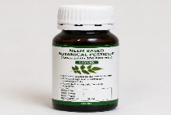
4 | Seedling tray | - Material: Durable, reusable UV-stabilized plastic.  - Number of cells: Minimum 50 holes per tray.  - Tray size: 50-55cm×27-30 cm  - Cell/Hole size (length* width/diameter*depth): minimum 5 cm×3-5cm×4-5cm  - Color: Black  - Suitable for tomato, cabbage, cauliflower, chilli, and similar vegetable seedlings.  - Strong and crack-resistant.  - Adequate drainage holes in each cell.  - Easy handling and transportation. |  |  | 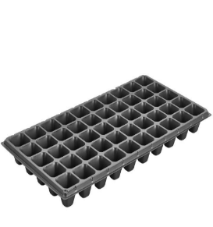
5 | Jholmol Drum | - Capacity: 50 liters.  - Material: UV-stabilized food-grade HDPE plastic.  - Color: Black  - With tightly fitting lid and side handles.  - Leak-proof and durable.  - Suitable for preparation and storage of Jholmol, Jeevamrit, and other liquid bio-inputs. |  |  | 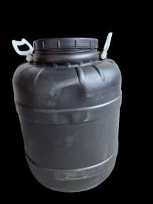
6 | Effective Mico-organism (EM) | - Type: Activated or concentrated Effective Microorganisms solution  - Packaging: 1-litre bottle, sealed plastic bottle.  - Shelf life: Minimum 6 months from delivery date.  - Free from contamination and sedimentation  - Clearly labeled with manufacturing and expiry dates. |  |  | 
7 | Hand Sprayer | - Capacity: 2 liters.  - Type: Manual hand-pressure sprayer.  - Material: Durable, UV-resistant plastic.  - Adjustable nozzle for mist and jet spray.  - Leak-proof design with ergonomic handle.  - Suitable for application of liquid fertilizers, botanical pesticides, and EM solutions. |  |  | 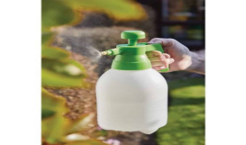
8 | Sprinkler | - Minimum 3 adjustable rotating arms with built-in spray nozzles minimum 2 per arms.  - Covers Approximately 5 to 8 Meters Diameter  - Material: Durable, UV-resistant plastic.  - Suitable for Vegetable Fields and agricultural purpose  - Easy to Use, simply connect it to the hose, and then start sprinkling away, with pointed ground stake base for firm anchoring in soil.  - 360° rotation, easily adjust spray 15-45 degrees upward and out  - Can operate in low water pressure  - Compatible with ½" or ¾" hose connection.  - Durable, rust-resistant, and suitable for field irrigation. |  |  | 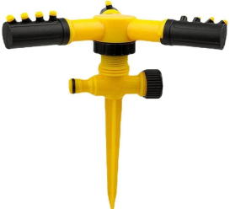
9 | Poultry Drinker | - Capacity: 5 liters  - Material: Food-grade durable plastic  - Type: Ground drinker  - Gravity fed design, Easy to clean and refill  - Stable base or stand to prevent spillage |  |  | 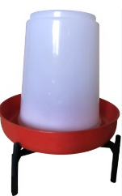
10 | Poultry Feeder | - Capacity: 5 kg  - Material: Food-grade durable plastic  - Type: hanging feeder  - Designed to minimize feed wastage  - Easy to clean |  |  | 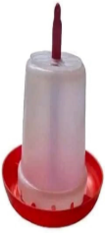
11 | Poultry Chick Feed | - Type: Commercial starter feed (B0)  - Packaging: 5 kg sack  - Crude protein content: Minimum 20-22%  - Free from mold, pests, and contaminants  - Properly sealed and labeled with manufacturing and expiry dates.

- Procedure for Submission of Tender
- Bidders must submit the following documents:
  - Technical Bid: It shall contain the information about the bidder i.e. experience and past performance in the execution of similar bids, capacity etc. and documents required for the bidding process.
  - Financial Bid: It shall contain the price quotation.
  - Deposit Slip: The bidders must deposit a sum equal to two and half percent of bid amount as Earnest Money at LI-BIRD’s bank account. Bidders must submit the deposit slip with the Financial Bid. The bank details are:
  - Account Name: LI-BIRD
  - Account Number: 1201017500829
  - Bank Name: Nabil Bank Ltd
  - Branch: Sabhagricha Chowk, Pokhara
Note: The deposited amount will be returned to the unsuccessful bidders within 7 days of the result announcement.
- Bidders must sign in each page of the Technical Bid Form in acceptance of terms and conditions laid down in the tender document, failing which it will be presumed that the bidder is not willing to accept the terms and conditions of the tender and will be liable for rejection.
- Both bidding forms should be enclosed in one big sealed envelope super-scribing “Tender for Supply of Agriculture Inputs 2026”.
- Bidders should invariably mention their name, address etc. on the left-hand side of the envelope for clear identification.

- EVALUATION CRITERIA
1. | Organizational Experience and Capacity (25)
1.1 | Years of Operation and General Experience in Agriculture Input Supply Sector (10)
1.2 | Specific Experience with Evidence of Successfully Completing at least 3 Similar Assignment in the last 3 years (10)
1.3 | Positive Feedback from Previous Clients specifically NGOs, INGOs, Government Agencies or Commercial Farms (5)
2. | Technical Compliance and Product Quality (35)
2.1 | Compliance with technical specification and supporting documentation (20)
2.2 | Durability and Performance of the Product with a proven active life exceeding the minimum (10)
2.3 | Compatibility Guarantee to ensure physical fit and chemical efficacy (5)
3 | Physical Verification Evaluation (40)
3.1 | Physical Verification of Product Quality, Materials, Construction, and Compliance with Specifications (20)
3.2 | Verification of Warehouse/Storage Facilities, Stock Availability, and Quality Control Systems (10)
3.3 | Verification of Logistics Capacity, Delivery Arrangements, Packaging, and Ability to Reach Remote Locations Without Damage (10)
The vendor will be selected based on the Quality and Cost Based Scoring (70:30)

Note: Submission Requirements and Shortlisting for Physical Verification
Bidders must submit adequate documentary evidence demonstrating their general experience, past performance, organizational capacity, and compliance with the required technical specifications. Failure to provide sufficient evidence supporting any of the mandatory evaluation criteria may result in the bidder receiving a low score or being deemed non-responsive during the Documentary Technical Evaluation stage. The evaluation process shall be conducted in two stages:
- Documentary Technical Evaluation (60 points)
- Physical Verification Evaluation (40 points)
Only bidders who achieve a minimum score of 40 out of 60 points in the Documentary Technical Evaluation shall be shortlisted and invited to proceed to the Physical Verification stage. Bidders scoring below 40 points in the Documentary Technical Evaluation shall be considered technically non-responsive and shall not be eligible for physical verification. The Physical Verification Evaluation will assess the bidder's actual capacity, including but not limited to product quality, stock availability, warehouse and storage facilities, quality control systems, and logistics arrangements.

The Total Technical Score shall be calculated by combining the Documentary Technical Evaluation score (60 points) and the Physical Verification Evaluation score (40 points), resulting in a maximum technical score of 100 points.

LI-BIRD reserves the right to conduct physical verification of the bidder's office, warehouse, inventory, equipment, product samples, and logistical capacity. Any significant discrepancy identified between the submitted documents and the findings of the physical verification may result in score reduction or disqualification.

- RECEIPT OF TENDERS
- The sealed tender should reach the office of LI-BIRD through Courier Service/By Hand only on or before 13 August 2026 up to 5:00 PM. Only hard copies of sealed bids shall be considered. No e-documents will be considered in the bidding process.
- The interested bidders can submit the sealed tender either at Programme Coordination Office of LI-BIRD at Sanepa, Lalitpur or at Head Office of LI-BIRD at Pokhara–11, Kaski.
- Tenders received after the schedule date and time shall not be entertained.

- TERMS AND CONDITION FOR SUPPLY OF AGRICULTURE INPUTS
- Bidders are requested to quote the price on a per unit basis for items mentioned in section B of this document.
- The rate quoted should be net including all costs (taxes) and delivery at the delivery points mentioned in section B of this document.
- LI-BIRD reserves the right to segregate the quantity of items between two or more bidders.
- LI-BIRD reserves the right to not proceed with this procurement at any stage or to accept or reject any or all applications without any explanation whatsoever.
- The successful bidder will be responsible for supply of agriculture inputs mentioned in the Bidding Form and quantities thereof as agreed.
- The successful bidder shall not change the committed quantities without the consent of LI-BIRD.

- PENALTY
- In case the successful bidder fails to supply the agreed quantities of Agriculture Inputs within the time period specified. LI-BIRD shall not be liable to pay the committed amount to the successful bidders.
- In case of any complaint received from the user or defect found on the Agriculture Inputs, the successful bidder would be liable to pay compensation as per the claims/decision reached through negotiation.
- Above penalty clauses shall not be applicable in case that natural calamity is the sole cause for the failure then LI-BIRD may waive the penalty, but it shall be sole discretion of LI-BIRD.

- SUBMISSION OF DOCUMENT AFTER SUPPLY OF AGRICULTURE INPUTS AND PAYMENT THEREOF
- The challan no. and date should invariably be indicated in the Invoice, when raised by the selected bidder.
- The successful bidder must in any case provide authorized bills after the successful delivery of the items.

- AGREEMENT AND OTHER TERMS AND CONDITIONS
- The bids will be opened on 14 August 2026 at 3:00 pm at LI-BIRD Head Office, Pokhara.
- The successful bidder will execute an agreement with LI-BIRD for arranging the supply of required value as per terms and conditions.
- If there arises any dispute between the parties, both will agree to accept the decision reached through mutual understanding.
- LI-BIRD has full right to accept or reject all or any bidder without assigning any reason thereof.

