Technical Bid
- General Information of the Bidder:
 | Name of the company/Organization
 | Address of Office
 | Office Contact Number
 | E Mail
 | Website
 | Name and designation of the representative of the tenderer to whom all references shall be made | - Name
 |  | - Designation
 |  | - Email
 |  | - Mobile No.
 | Refundable Earnest Money Deposited |  | Submit Deposit Slip
 | Nature of the Company |  | Proprietary/Partnership/ Private Ltd/ Public Ltd
 | Proprietor/Partner/Chief Executive Name and Contact No. | - Name
 | Proprietor/Partner/Chief Executive Name and Contact No. | - Mobile No.
 | Nature of Business |  | Distributor/Dealer/Trader/Manufacturer
 | Year of starting business
 | Scope (Category) of Supply
 | Registration Certificate |  | Submit copy
 | Renewal Certificate |  | Submit copy
 | Supplier Declaration Form |  | Submit duly filled, signed and stamped Form
FINANCIAL & COMMERCE
 | Bank Detail of Tenderer | - Account Name
 | Bank Detail of Tenderer | - Account No.
 | Bank Detail of Tenderer | - Account Type
 | Bank Detail of Tenderer | - Bank Name
 | Bank Detail of Tenderer | - Bank Branch
 | Value of total sales during the previous Year
 | Tax Clearance certificate |  | Submit copy
 | Cliental List |  | Enclose details indicating name with address of customer, product supplied and year of supply
 | PAN/VAT Registration Certificate |  | Submit copy
 | Pictures of the items quoted for along with the detail specification |  | Submit Pictures and Detail Specification of the items (Bidders must submit the pictures of all the items they have quoted for along with the detail specification and user manual if any)
 | After Sales Service |  | Submit detail of after sales service
 | Any additional information you would like to provide??
Note: Please fill in the vendor registration form for FY 2083/84 if you or your firm is not registered in LI-BIRD’s vendor roster. Refer to the following link for the Vendor Registration Form: LI-BIRD - Vendor Registration Form 83/84

- Technical Specification
B.1. Scope of Work
The scope of work of the vendor is the supply and delivery of high-quality agriculture inputs and agri machinery to support beneficiaries of Green Evolution project in Surkhet, Jumla and Dailekh sites. The vendor will be fully responsible for ensuring that all supplied items strictly confirm to the approved technical specifications and quality standards with timely delivery of the items to designated delivery points. The items with the delivery points are as follows:
S.N. | Items | Unit | Total Quantity | Delivery Point | Remarks
1 | Bee Swarm Trap (Swarming Bag) | Nos | 20.00 | 10 Pcs in Birendranagar Site Office, Surkhet  5 Pcs in Dullu Site office, Dailekh  5 Pcs in Tatopani RM, Jumla
2 | Bee Veil | Nos | 20.00 | 10 Pcs in Birendranagar Site Office, Surkhet  5 Pcs in Dullu Site office, Dailekh  5 Pcs in Tatopani RM, Jumla
3 | Queen Gate | Nos | 15.00 | 5 Pcs in Birendranagar Site Office, Surkhet  5 Pcs in Dullu Site office, Dailekh  5 Pcs in Tatopani RM, Jumla
4 | Queen Cage | Nos | 20.00 | 10 Pcs in Birendranagar Site Office, Surkhet  5 Pcs in Dullu Site office, Dailekh  5 Pcs in Tatopani RM, Jumla
5 | Hive Smoker | Nos | 20.00 | 10 Pcs in Birendranagar Site Office, Surkhet  5 Pcs in Dullu Site office, Dailekh  5 Pcs in Tatopani RM, Jumla
6 | Beekeeping Gloves | Pair | 20.00 | 10 Pcs in Birendranagar Site Office, Surkhet  5 Pcs in Dullu Site office, Dailekh  5 Pcs in Tatopani RM, Jumla
7 | Bee Feeder | Nos | 15.00 | 5 Pcs in Birendranagar Site Office, Surkhet  5 Pcs in Dullu Site office, Dailekh  5 Pcs in Tatopani RM, Jumla
8 | Honey Extractor- Cerena Bee | Nos | 3.00 | 1 Pcs in Birendranagar Site Office, Surkhet  1 Pcs in Dullu Site office, Dailekh  1 Pcs in Tatopani RM, Jumla
9 | Honey Extractor- Mellifera Bee | Nos | 1.00 | 1 Pcs in Birendranagar Site Office, Surkhet
10 | Seed Grading and cleaning machine | Nos | 2.00 | 1 Pcs in Dullu Site Office, Dailekh  1 Pcs in Tatopani RM Office, Jumla
11 | Drum | Nos | 20.00 | 12 Pcs in Birendranagar Site Office, Surkhet  8 Pcs in Dullu Site Office, Dailekh
12 | Packaging sacks | Pcs | 700.00 | 500 Pcs for Birendranagar Site Office, Surkhet  100 Pcs for Dullu site Office, Dailekh  100 Pcs for Tatopani RM, Jumla
13 | Combined Mill (Electric) | Nos | 4.00 | 2 Pcs for Birendranagar Site Office, Surkhet  2 Pcs for Dullu site Office, Dailekh
14 | Metal Seed Storage Bins set | Set | 4.00 | 1 Set for Birendranagar Site Office, Surkhet  2 Set for Dullu site Office, Dailekh  1 Set for Tatopani RM, Jumla
15 | Plastic Crates | Nos | 180.00 | 60 Pcs for Birendranagar Site Office, Surkhet  60 Pcs for Dullu site Office, Dailekh  60 Pcs for Tatopani RM, Jumla
16 | Hermetic Bags | Nos | 300.00 | 100 Pcs for Birendranagar Site Office, Surkhet  150 Pcs for Dullu site Office, Dailekh  50 Pcs for Tatopani RM, Jumla
17 | Plastic Tunnel | Nos | 30.00 | 30 Pcs for Tatopani RM, Jumla
18 | Belt for Plastic Tunnel | Nos | 30.00 | 30 Pcs for Tatopani RM, Jumla
19 | Plastic for Pond | Nos | 1.00 | 1 Pcs for Dullu Site office, Dailekh
20 | Digital balance (Seed weighing) | Nos | 2.00 | 1 Pcs for Dullu Site office, Dailekh  1 Pcs for Tatopani RM, Jumla
21 | Weighing balance 100kg | Nos | 6.00 | 2 Pcs for Birendranagar Site Office, Surkhet  2 Pcs for Dullu Site office, Dailekh  2 Pcs for Tatopani RM, Jumla
22 | Green net for nursery | Nos | 7.00 | 5 Pcs for Birendranagar Site Office, Surkhet  2 Pcs for Dullu Site office, Dailekh
23 | Sack sewing machine | Nos | 2.00 | 2 Pcs for Birendranagar Site Office, Surkhet
24 | Plastic sealing machine | Nos | 2.00 | 1 Pcs for Birendranagar Site Office, Surkhet  1 Pcs for Dullu Site office, Dailekh
25 | Knapsack Sprayer | Nos | 30.00 | 5 Pcs for Birendranagar Site Office, Surkhet  25 Pcs for Dullu Site office, Dailekh
26 | Jute Sacks | Nos | 300.00 | 100 Pcs for Birendranagar Site Office, Surkhet  100 Pcs for Dullu site Office, Dailekh  100 Pcs for Tatopani RM, Jumla
27 | Tripal (Tarpaulin) Sheets | Nos | 30.00 | 10 Pcs for Birendranagar Site Office, Surkhet  10 Pcs for Dullu site Office, Dailekh  10 Pcs for Tatopani RM, Jumla
Note: The detailed specification of different items should comply with Section B.2. Compliance with Specification

B.2. Compliance with Specifications
The technical specifications are a minimum checklist for evaluating compliance; referenced brands or models or pictures are indicative only, and equivalent equipment is acceptable. For each item, bidders shall write “Yes, in compliance with specification” and cite relevant reference documents in the next column; if there is any deviation, it must be clearly stated in the compliance column.
S.N. | Items | Specifications | Compliance with Specification | Reference Document (Specify Document) | Reference Picture
1 | Bee Swarm Trap (Swarming Bag) | - Material: Durable, reusable cloth made of breathable fabric (Cotton canvas or equivalent)  - Dimensions: Approx. 45 cm * 65 cm  - Color: Light or neutral color preferred  - Ventilation: Adequate airflow to maintain bee health during temporary containment  - Use: Used to collect Bee from outside |  |  | 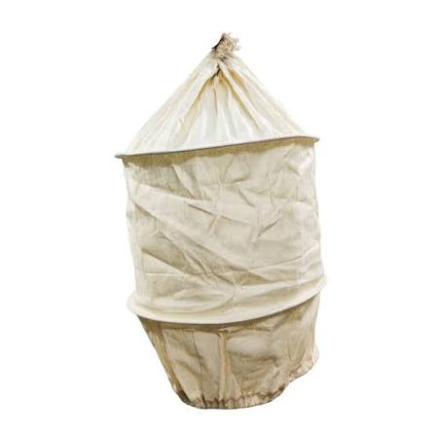
2 | Bee Veil | - Material: High-quality cotton/polyester cloth with fine mesh netting  - Diameter: 35-40 cm,  - Length (Veil/Net): 30-50 cm  - Color: Light Color preferred (white or khaki)  - Use: Bee hive Management |  |  | 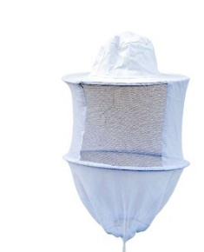
3. | Queen Gate | - Material: Galvanized Zinc plate attached with wooden piece.  - Length: 15-25 cm  - Width: Suitable for standard beehive entrance dimensions  - Use: Protect Queen from Hive to escape |  |  | 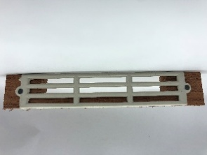
4 | Queen Cage | - Material: High Quality, Durable, Non-Toxic Plastic  - Length: 10-15 cm  - Color: Any standard commercial manufacture color.  Use: Protect queen within Bee hive |  |  | 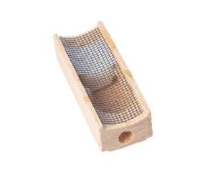
5 | Hive Smoker | - Material: Stainless steel body with heat resistant components  - Bottle size: Approx. 10*25 cm,  - Fuel Compatibility: Suitable for use with dried leaves, wood shavings, pine needles, burlap, cardboard, or other commonly used smoker fuels.  - Use: Bee Hive Management |  |  | 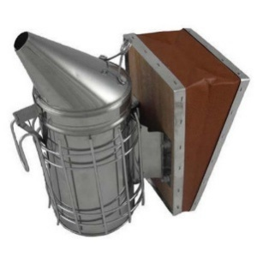
6 | Beekeeping Gloves | - Material: Durable cotton or canvas cloth globes with extended protective sleeves and breathable mesh/net  - Length: Full length 50 cm (including forearm protection)  - Use: Bee Hive Management |  |  | 
7 | Bee Feeder | - Material: High Quality Food Grade Plastic resistant to cracking and weather exposure  - Type: Tray-Type Feeder  - Dimension: Aprox. 48.5*12cm  Capacity: 1-2 Liters  Use: Bee Feeding |  |  | 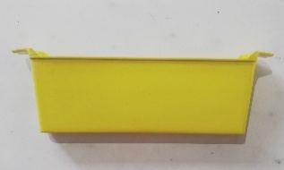
8 | Honey Extractor: Cerena | - Type: Manual honey extractor suitable for Cerana honey bee frames,  - Capacity of 4 frames (2 brooding chamber frame and 2 honey chamber frames)  - Material: Food-grade stainless steel (drum, basket and honey-contact parts)  - Drum Capacity: Suitable to accommodate four standard Cerena frames simultaneously |  |  | 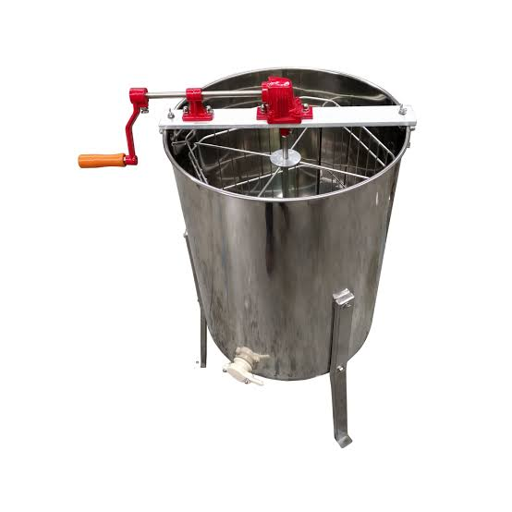
9 | Honey Extractor: Mellifera | - Type: Manual honey extractor suitable for Mellifera honey been frames  - Capacity: 8 frames  - Material: Food-grade stainless steel (drum, basket and honey-contact parts)  - Drum Capacity: Suitable to accommodate eight standard mellifera frames simultaneously |  |  | 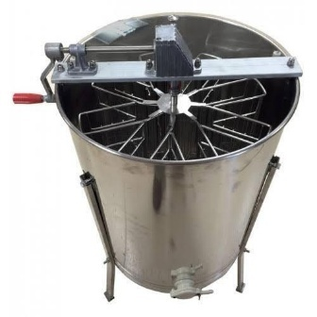
10 | Seed Grading and Cleaning Machine | - Type: Electrically operated seed grading and cleaning machine  - Motor: 0.5 HP-1 HP, Single-phase  - Capacity: 450-550 kg/hour (depending on seed type, moisture content, and impurities).  - Layers: Three-layer sieve system with interchangeable screens for different seed sizes  - Blower: Integrated adjustable blower/fan for removal of light impurities such as dust, chaff, empty seeds, and husk.  - Material: Main body fabricated from mild steel with rust-resistant paint finish or equivalent and Seed-contact parts made of galvanized steel, stainless steel or other non-corrosive material  - Suitable for: Grains, beans, and vegetable seeds |  |  | 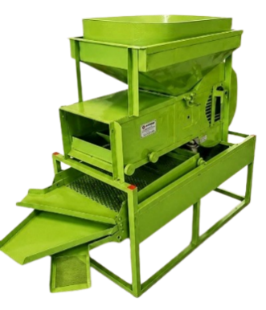
11 | Drum | - Type: HDPE Storage Drum  - Capacity: 250 ltrs  - Weight: Approx. 8-12 Kg  - Color: Blue  - Design: Cylindrical with removable lid type drum  - Use: for biopesticides formulation and storage |  |  | 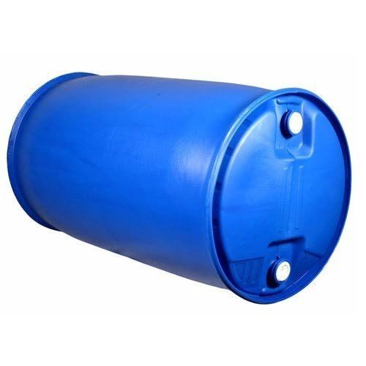
12 | Packaging sacks | - Type: Woven packaging sack for agri produce and inputs  - Capacity: 25 kg  - Material: High quality Polypropylene woven fabric (moisture proof)  - Color: White or other standard commercial color |  |  | 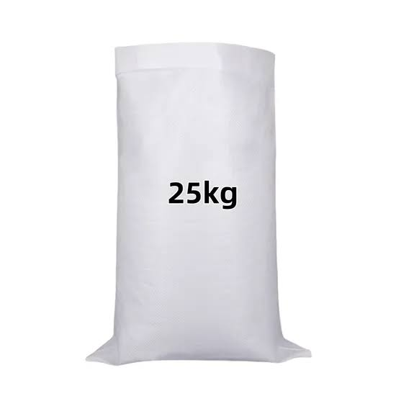
13 | Combined mill (Electric) | - Motor Power: 3-3.5 HP Electric Motor  - Weight: Approx. 60-75 Kg  - Rice Milling Capacity: 120-180 Kg/hr (approx..)  - Grain Grinder Capacity: 120-200 Kg/hr (approx.)  - Body Material: Heavy-duty iron or fabricated iron body with corrosion-resistant paint finish  - Roller speed (Rice Mill): 2000-3000 rev/min  - Mode of operation: Electric (single phase)  - Use: Milling rice, & grinding wheat, millet and turmeric (spices) |  |  | 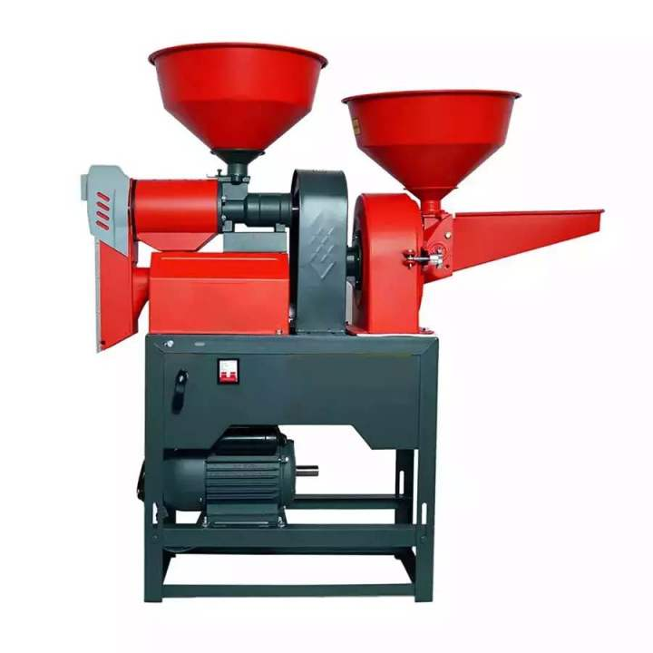
14 | Metal Seed Storage Bins set | - Type: Metal seed and grain storage bin set consisting of 5 bins of different capacities  - Material: High-quality Galvanized Iron (GI) sheet  - Thickness: 30–35-gauge GI sheet  - Structure: Cylindrical/round shape with vertical body  - Set Composition: One set comprising of 5 bins of varying capacities ranging from 70-150 kg  - Uses: Suitable for grain and seed storage |  |  | 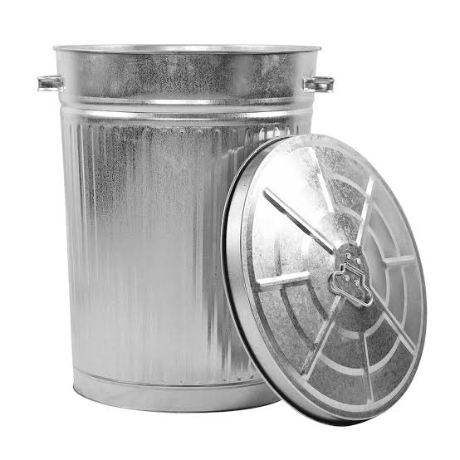
15 | Plastic Crates | - Type: Heavy-duty plastic crate for harvesting, collection, transportation, and storage of fruits and vegetables  - Material: HDPE  - Dimensions: 54*35*27 cm;  - Wall Thickness: 3-5 mm;  - Crate Weight: 1-2 Kg  - Color: Any standard commercial color |  |  | 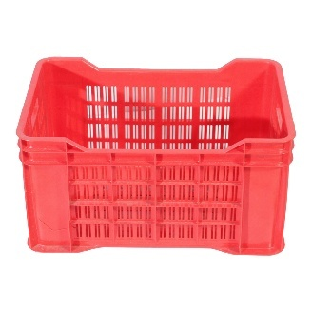
16 | Hermetic Bags | - Type: Triple-layer hermetic storage bag for grain  - Capacity: 50 Kg  - No. of layers: 3 (one outer layer made of standard Polypropylene woven bag, two inner layers made up of High-density polyethylene)  - Capacity: 50 kg, Air tight bag with air lock. |  |  | 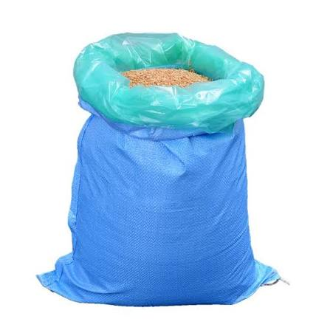
17 | Plastic tunnel | - Material: Waterproof and UV Resistant; ISO Certified  Crafted with plastic life HDPE and LDPE  - Thickness: 120 GSM  - Color: White (Natural)  - Size: 12m*6m |  |  | 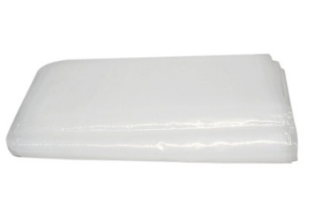
18 | Belt for Plastic Tunnel | - Material: Greenhouse poly propylene belt suitable for greenhouse and tunnel applications  - Properties: UV, wind and weather resistant  - Length: 80-100 m;  - Width: 3 mm  - Color: Black or White |  |  | 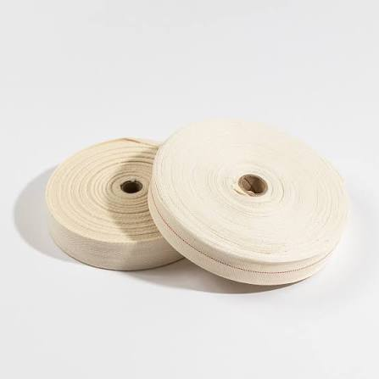
19 | Plastic Sheet for Pond | - Material: HDPE  - Size: 12*8 meters  - Thickness: 250 GSM  - Color: Blue  - Usage: For Water Storage Pond |  |  | 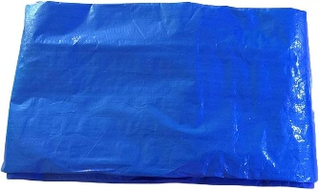
20 | Digital balance (Seed weighing) | - Type: Electronic digital weighing balance  - Min. weighing range: 1 gm  - Max. Weighing Capacity: 3-5 Kg  - Accuracy: High precision electronic weighing system with + 1 g accuracy  - Display: LCD Display with clear weight indication  - Platform Material: Stainless steel or corrosion resistant weighing pan/platform  - Power Source: Rechargeable battery and/or AC power adapter  - Certification: ISO 9001 certification  - Use: Suitable for commercial or laboratory use |  |  | 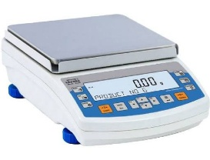
21 | Weighing Balance (100kg | - Weighing Capacity: 100 Kg  - Readability/Graduation: 10 g to 20 g  - Accuracy: High-precision electronic weighing system suitable for commercial and agri use  - Platform material: Stainless steel or heavy-duty mild steel platform with corrosion-resistant finish  - Platform Size: Minimum 40 cm × 50 cm or equivalent suitable for weighing sacks, seeds, grains, agricultural products, and inputs.  - Display: Large, easy-to-read digital LCD/LED display mounted on a stand/pole.  - Stand: Integrated metal stand/pole for elevated display visibility during operation.  - Power Supply: Rechargeable battery with AC power adapter.  - Certification: Manufacturer certified under ISO 9001 Quality Mgmt. System or equivalent and complies with applicable Nepal Standards (NS) |  |  | 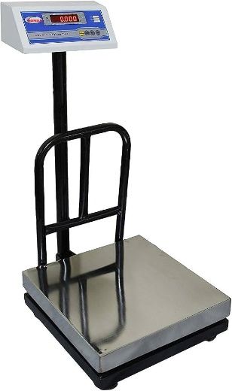
22 | Green net for nursery | - Type: Agri shade net for nursery and protected cultivation  - Material: UV stabilized high-density Polyethylene  - Dimension: 3 m * 50 m,  - Thickness: 75-90 GSM, 75% shade  - Color: Green |  |  | 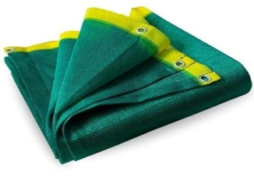
23 | Sack sewing machine | - Type: Portable electric sack sewing machine for closing woven and multilayer bags  - Material: Mild Steel  - Motor: 0.20-0.30 HP  - Power: Electric  - Weight: 3-4 Kg,  - Material Stitching Capacity: Suitable for stitching bag materials with thickness of 2-5 mm  - Thread: Single thread  - Sewing Speed: 1500-1800 stitches per minutes |  |  | 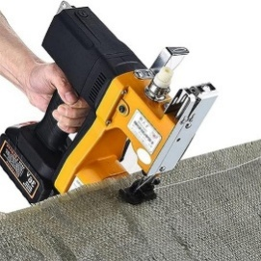
24 | Plastic sealing machine | - Type: Continuous vertical band sealing machine for sealing plastic and laminated packaging bags  - Sealing Length: 14- 16 inches (400 mm)  - Seal Width: 3 mm provides a professional seal.  - Sealing capacity: Suitable for packaging materials with thickness ranging from 6-12 mm  - Power: 500- 600W or more for efficiency.  - Machine Body: Heavy-duty metal construction with corrosion-resistant finish suitable for commercial operation.  - Vertical Band Sealer features: Energy-efficient impulse heating, adjustable timer |  |  | 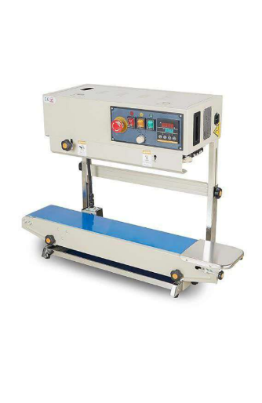
25 | Knapsack Sprayer | - Type: Manual Knapsack Sprayer for agricultural and horticultural applications  - Mode of operation: Manual  - Tank Capacity: 16 liters  - Tank Material: HDPE or equivalent durable, UV resistant plastic  - Color: Any standard commercial color  - Carrying system: Adjustable and padded back-carry shoulder straps  - Hose: Flexible, chemical-resistant high-pressure hose  - Nozzle: Adjustable nozzle |  |  | 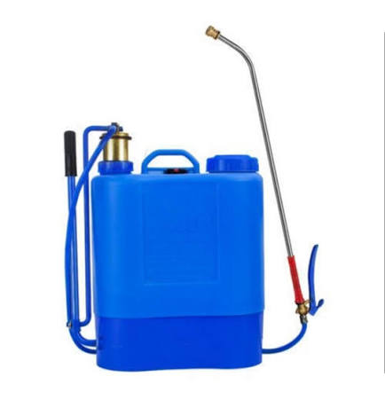
26 | Jute Sacks | - Material: 100% natural jute fiber, woven and durable  - Capacity: 100 Kg  - Color: Natural jute color (brown) or equivalent |  |  | 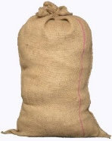
27 | Tripal (Tarpaulin) Sheets | - Material: HDPE (Lightweight PE Plastic Tarp), Water resistant ground sheet  - Color: Blue  - Dimension: 12ft x 15ft  - GSM: 120 GSM  - Use: Multipurpose Small Tarpaulin Covers used for Shed, drying material and agriculture purpose |  |  | 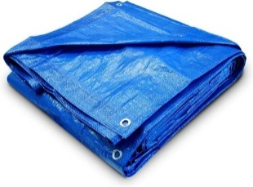

- Procedure for Submission of Tender
- Bidders must submit the following documents:
  - Technical Bid: It shall contain the information about the bidder i.e. experience and past performance in the execution of similar bids, capacity etc. and documents required for the bidding process.
  - Financial Bid: It shall contain the price quotation.
  - Deposit Slip: The bidders must deposit a sum equal to two and half percent of bid amount as Earnest Money at LI-BIRD’s bank account. Bidders must submit the deposit slip with the Financial Bid. The bank details are:
  - Account Name: LI-BIRD
  - Account Number: 1201017500829
  - Bank Name: Nabil Bank Ltd
  - Branch: Sabhagricha Chowk, Pokhara
Note: The deposited amount will be returned to the unsuccessful bidders within 7 days of the result announcement.
- Bidders must sign in each page of the Technical Bid Form in acceptance of terms and conditions laid down in the tender document, failing which it will be presumed that the bidder is not willing to accept the terms and conditions of the tender and will be liable for rejection.
- Both bidding forms should be enclosed in one big sealed envelope super-scribing “Tender for Supply of Agriculture Inputs and Agri Machinery Items 2026”.
- Bidders should invariably mention their name, address etc. on the left-hand side of the envelope for clear identification.

- EVALUATION CRITERIA
I | Documentary Technical Evaluation (60 Marks)
1. | Organizational Experience and Capacity (20)
1.1 | Years of Operation and General Experience in Agriculture Inputs and Agri Machinery Supply (5)
1.2 | Specific Experience with Evidence of Successfully Completing at least 3 Similar Assignment in the last 3 years (10)
1.3 | Positive Feedback from Previous Clients specifically NGOs, INGOs, Government Agencies or Commercial Farms (5)
2. | Technical Compliance and Product Quality (30)
2.1 | Compliance with technical specification and supporting documentation (20)
2.2 | Catalogs, brochures, manufacturer specifications, certifications (10)
3. | Delivery, Logistics and After-Sales Support (10)
3.1 | Delivery plan and Lead time (5)
3.2 | Warranty commitment, After-sales service, technicians and spare parts support (5)
II | Physical Verification Evaluation (40 Marks)
1 | Physical Verification of Product Quality, Materials, Construction, and Compliance with Specifications (20)
1.1 | Verification of Product Quality and Compliance with specification (10)
1.2 | Demonstration and Operational Performance (10)
2 | Capacity, Logistics and Service Infrastructure Verification (20)
2.1 | Warehouse, Inventory and Quality Control System (10)
2.2 | Delivery and Logistics Capacity (5)
2.3 | After-Sales Service Infrastructure (5)
The vendor will be selected based on the Quality and Cost Based Scoring (70:30)

Note: Submission Requirements and Shortlisting for Physical Verification
Bidders must submit adequate documentary evidence demonstrating their general experience, past performance, organizational capacity, and compliance with the required technical specifications. Failure to provide sufficient evidence supporting any of the mandatory evaluation criteria may result in the bidder receiving a low score or being deemed non-responsive during the Documentary Technical Evaluation stage. The evaluation process shall be conducted in two stages:
- Documentary Technical Evaluation (60 points)
- Physical Verification Evaluation (40 points)
Only bidders who achieve a minimum score of 40 out of 60 points in the Documentary Technical Evaluation shall be shortlisted and invited to proceed to the Physical Verification stage. Bidders scoring below 40 points in the Documentary Technical Evaluation shall be considered technically non-responsive and shall not be eligible for physical verification. The Physical Verification Evaluation will assess the bidder's actual capacity, including but not limited to product quality, stock availability, warehouse and storage facilities, quality control systems, and logistics arrangements.

The Total Technical Score shall be calculated by combining the Documentary Technical Evaluation score (60 points) and the Physical Verification Evaluation score (40 points), resulting in a maximum technical score of 100 points.

LI-BIRD reserves the right to conduct physical verification of the bidder's office, warehouse, inventory, equipment, product samples, and logistical capacity. Any significant discrepancy identified between the submitted documents and the findings of the physical verification may result in score reduction or disqualification.

- RECEIPT OF TENDERS
- The sealed tender should reach the office of LI-BIRD through Courier Service/By Hand only on or before 16 November 2026 up to 5:00 PM. Only hard copies of sealed bids shall be considered. No e-documents will be considered in the bidding process. Note that LI-BIRD office will remain closed on Saturdays and Sundays, as well as from 9 November to 13 November 2026 due to the Tihar Holidays.
- The interested bidders can submit the sealed tender either at Programme Coordination Office of LI-BIRD at Sanepa, Lalitpur or at Head Office of LI-BIRD at Pokhara–11, Kaski.
- Tenders received after the schedule date and time shall not be entertained.

- TERMS AND CONDITION FOR SUPPLY OF AGRICILTURE INPUTS AND AGRI MACHINERY ITEMS
- Bidders are requested to quote the price on a per unit basis for items mentioned in section B of this document.
- The rate quoted should be net including all costs (taxes) and delivery at the delivery points mentioned in section B of this document.
- LI-BIRD reserves the right to segregate the quantity of items between two or more bidders.
- LI-BIRD reserves the right to not proceed with this procurement at any stage or to accept or reject any or all applications without any explanation whatsoever.
- The successful bidder will be responsible for supply of Agri Machinery Items mentioned in the Bidding Form and quantities thereof as agreed.
- The successful bidder shall not change the committed quantities without the consent of LI-BIRD.

- PENALTY
- In case the successful bidder fails to supply the agreed quantities of Agriculture Inputs and Agri Machinery Items within the time period specified. LI-BIRD shall not be liable to pay the committed amount to the successful bidders.
- In case of any complaint received from the user or defect found on the Agriculture Inputs and Agri Machinery Items, the successful bidder would be liable to pay compensation as per the claims/decision reached through negotiation.
- Above penalty clauses shall not be applicable in case that natural calamity is the sole cause for the failure then LI-BIRD may waive the penalty, but it shall be sole discretion of LI-BIRD.

- AGREEMENT AND OTHER TERMS AND CONDITIONS
- The bids will be opened on 17 November 2026 at 3:00 pm at LI-BIRD Head Office, Pokhara.
- The successful bidder will execute an agreement with LI-BIRD for arranging the supply of required value as per terms and conditions.
- If there arises any dispute between the parties, both will agree to accept the decision reached through mutual understanding.
- LI-BIRD has full right to accept or reject all or any bidder without assigning any reason thereof.

